### 

### 

CS691 – Computer Science, Fall 2020

Pace University



SYSTEM TEST PLAN

**Stream Feeder**

Authors: Prajakta Jathar

Project Manager: Manisha Shinde

Date: 06/11/20

**Table of Contents**

***INTRODUCTION 3***

***1.TESTING SCOPE 3***

***2.TESTING OBJECTIVES 3***

**2.1 Features to be Tested 3**

**2.2 Features not to be Tested 4**

***3．TEST PROCESS DEFINITION 4***

**3.1 Test Process Phases and Tasks 4**

**3.2 Deliverables 5**

***4. APPROACH TO SYSTEM TESTING 6***

**4.1 Approach to Functional Testing 6**

***5. ENTRY/EXIT CRITERIA 6***

**5.1 Entry Criteria 6**

**5.2 Exit Criteria 6**

***6. ENVIRONMENTAL NEEDS 6***

***7. ROLES AND RESPONSIBILITIES 7***

***8. TEST CYCLES AND SCHEDULE 8***

9. ***RISKS AND CONTINGENCIES 8***

# **INTRODUCTION**

The primary purpose of the System Test Plan document is to establish a common understanding among the "Stream Feeder" project stakeholders about the scope, objectives, and approach to performing the system testing. Also, the document explains the features to be tested, testing entry/exit criteria, resource and responsibilities, and testing schedule.

# **1.TESTING SCOPE**

The testing scope includes two perspectives - the functional scope and technical scope.

The functional scope includes the following modules of the “Stream Feeder” system: User Experience and User Registration/Login.

The technical scope includes the following architectural components:

* Web browser
* Application server
* Database server
* Content server

# **2.TESTING OBJECTIVES**

The main objective of system testing is to validate the implementation of the system features for compliance with their functional and non-functional requirements. The non-functional testing requires some special tooling to monitor performance characteristics, which is not available on this project.

The basis for developing functional tests and evaluating the system functionality includes the following sources:

* Business Requirements Document (BRD)
* User Stories - External User, Internal User (functional requirements)
* Requirements Composition Table (supplementary requirements)

## 2.1 Features to be Tested

This section lists all core features that will be tested grouped by the application modules below.

User Experience

* I Have Input
  + To test whether the user is successfully able to input userid and password therefore essential in order to protect user security and Identity.
  + It switch to more secure app.
* I have Item Like & Dislike
  + To test whether the user is successfully able to like and dislike on post from social media feeds.
* Email Address
  + To test whether a user can successfully login using email to secure the application on their side.

User Register/Login

* User Registration
  + Test whether a user can register/create account.
* User Login
  + Test whether a user can login once they have registered.

Besides the core features in the scope of testing, the function testing also will cover crosscutting concerns that are applicable to the context of the individual core features (refer to the RCT).

## 2.2 Features not to be Tested

As mentioned above, system performance will not be tested for the lack of required tools. Also, usability and security will not be tested as well.

# 

# **3．TEST PROCESS DEFINITION**

## 3.1 Test Process Phases and Tasks

The test process for system testing can be defined as the following five phases:

* Test Planning
* Test Design
* Test Preparation
* Test Execution
* Test Reporting

The purpose of the **Test Planning** phase is to define the scope and objectives of testing, roles and responsibilities, and to define the testing approach.

The purpose of the **Test Design** phase is to determine the test design logic, to design test case specifications, and to determine requirements for test data.

In the **Test Preparation** phase, the objective is to setup a test environment, provision test data, and install the software under test in the QA environment.

The purpose of the **Test Execution** phase is to execute all test cases and to find and report software defects. The ultimate goal here is to evaluate the system stability by validating all features identified to be tested in the System Test Plan document.

The purpose of the **Test Reporting** phase is to provide stakeholders with visibility into the progress and completion of test execution. Testers will report defect metrics, produce test execution status reports, and evaluate the test exit criteria in the Test Completion Report. The approval of this report will be a basis for system testing sign off.

* Test Planning
  + Define scope and objectives of testing
  + Define roles and responsibilities
  + Define testing approach
* Test Design
  + Identify test ideas, define an approach to designing test cases
  + Develop test case specifications
  + Measure test coverage
  + Determine requirements for test data
* Test Preparation
  + Setup a test environment
  + Provision test data
  + Install the software in the test environment
* Test Execution
  + Execute all test cases
  + Find and report software defects
  + Evaluate the system stability
  + Validate all target features
* Test Reporting
  + Summarize and report the test execution results
  + Report defect metrics
  + Evaluate the test exit criteria
  + Create a test completion report, submit for stakeholder approval
  + Obtain stakeholder signoff on system testing

## 3.2 Deliverables

On this project, the test process deliverables include:

* System Test Plan document
* Test Design specifications
* Test Case specifications
* Test Execution Logs
* Test Completion Report

# **4. APPROACH TO SYSTEM TESTING**

## 4.1 Approach to Functional Testing

The System Test will be performed based on the black-box techniques. This means, first, that the external functional specifications or business rules will be used as a primary source to design test conditions. Secondly, testing will be executed from the user perspective, i.e., considering the system as a black box and entering input data and evaluating results via the user interface.

The test execution results will be captured and reported in test execution logs.

# **5. ENTRY/EXIT CRITERIA**

This section defines both Entry and Exit Criteria for test execution and is intended to establish a common understanding about the conditions when the test execution can start and when it can stop.

## 5.1 Entry Criteria

The test Entry Criteria include the following items:

* The application build is produced and deployed to the test app
* The system test plan is produced and approved
* The test app is ready for testing
* Test Designs and test case specifications are completed
* Test case specifications have been completed and reviewed

## 5.2 Exit Criteria

The test Exit Criteria include the following items:

* All test cases have been executed
* Zero defects of Critical and Hi-severity remain open
* Open defects of Medium and Low severity have known work-arounds
* Test Summary report is produced and published

# **6. Business Needs**

Streamfeeder aims to add value through providing an interface that will intertwine these platforms, thereby enhancing the user experience, and bringing their much-desired content into one application. The main agenda of our app is to create a web application that will be able to take the best of each of these platforms, find the commonalities among them, and combine them into a single application for ease of use and availability of information. The Architecture of streamfeeder is shown below.

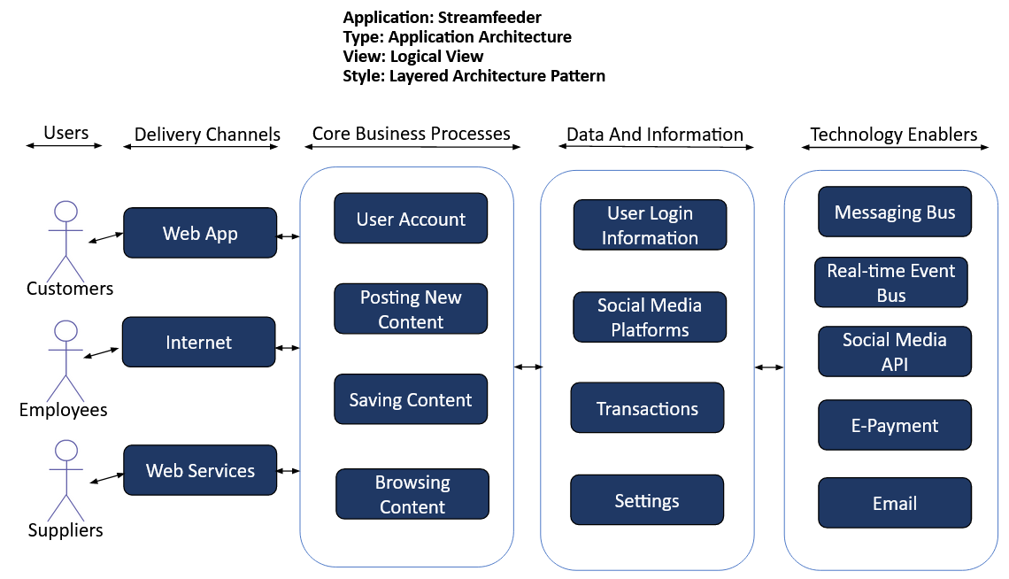

# **7. ROLES AND RESPONSIBILITIES**

The project team has seven members that are assigned various project roles including Project Manager, Product Owner, Lead Business Analyst, Lead Developer, DBA, Lead QA Analyst. Their responsibilities are defined in the table below.

|  |  |
| --- | --- |
| **Project Role** | **Role Responsibilities** |
| Project Manager | Reviewing and approving the System Test Plan, test design specifications.  Managing the test environment preparation.  Tracking the testing schedule and results. |
| Lead QA Analyst | Designing a test plan, establishing a test repository, developing test case specifications, executing testing and reporting defects. |
| Product Owner | Contributing to the test plan and test case specifications. Reviewing test results. |
| Lead Business Analyst | Contributing to the test plan and test case specifications. Reviewing test results. |
| Lead Developer | Establishing and maintaining the test environment, assisting a Lead QA Analyst throughout the testing process. |
| DBA | Assisting the Lead Developer in establishing and maintaining the test environment. |

# **8. TEST CYCLES AND SCHEDULE**

The system test execution will be conducted as three test cycles that are aligned with three application modules as follows:

Cycle 1. Browse Content

* This cycle concentrates on testing the browse webpages of Graphical User Interface.

Cycle 2. User Register/Login

* This cycle concentrates on testing the Payment and User Register/Login Module.

See the schedule of the test execution cycles in the project plan.

# **9. RISKS AND CONTINGENCIES**

This section highlights a few potential risks and contingencies that maybe happened during the system testing.

* Limited testing resource may result in a delay.
* Any changes on the scope objectives can cause a delay or extra work.
* A large number of defects require a longer time to fix defects and complete testing.
* Lack of collaboration of the team members can have a negative impact on the testing progress.

# 